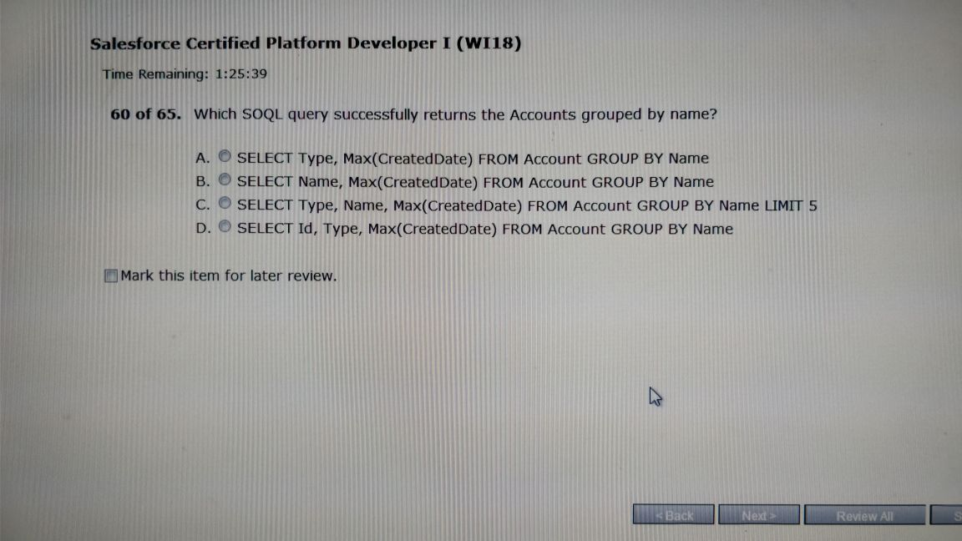

B

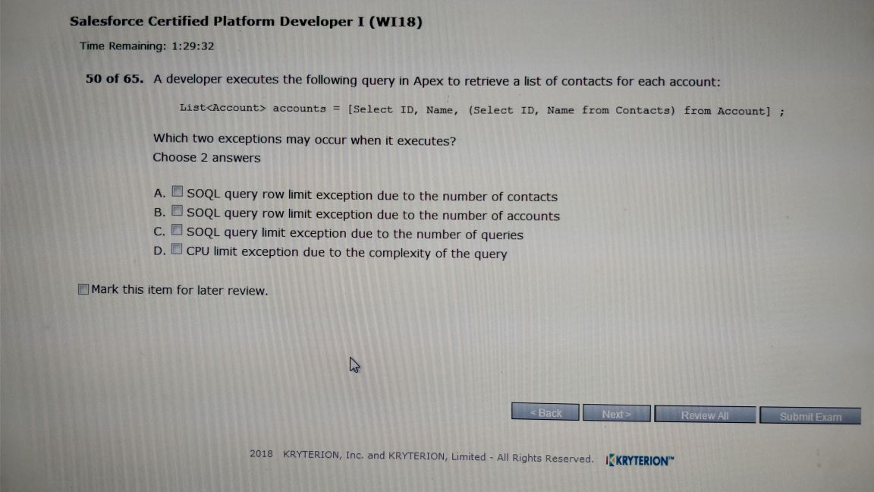

A,B

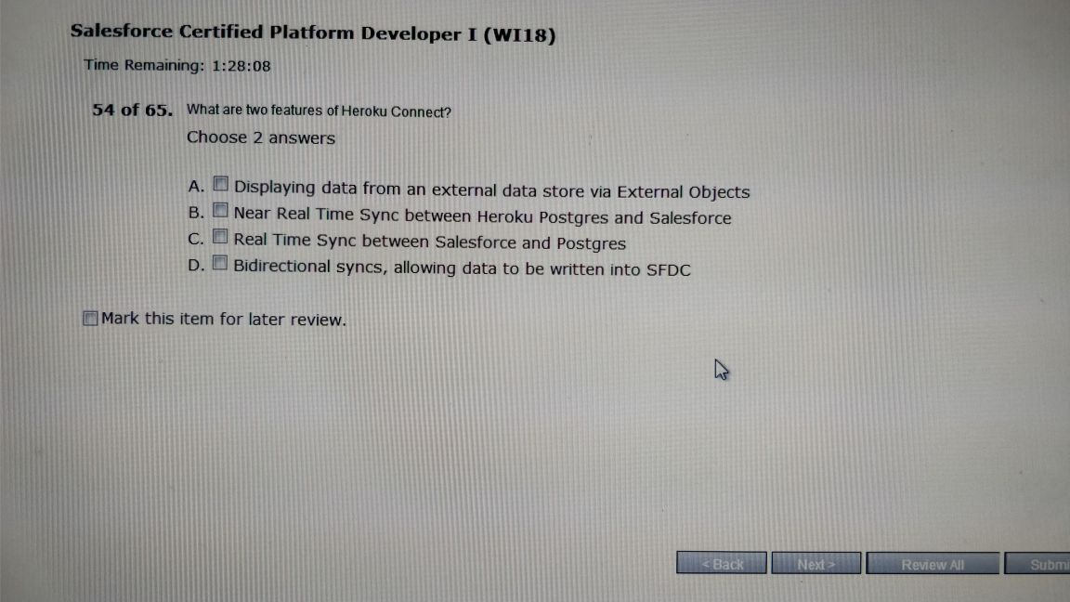

A,D

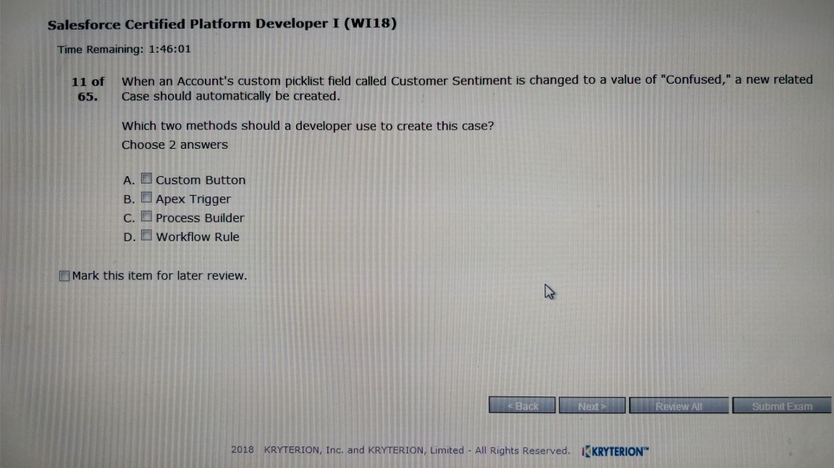

B,C,

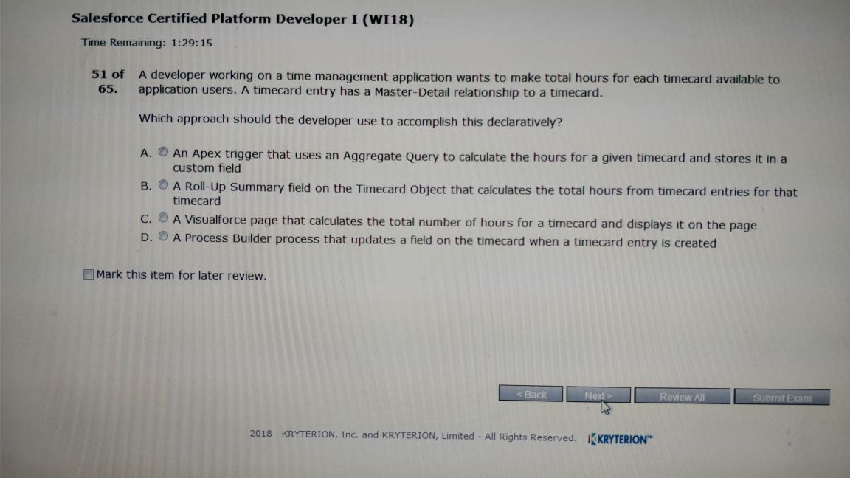

B.

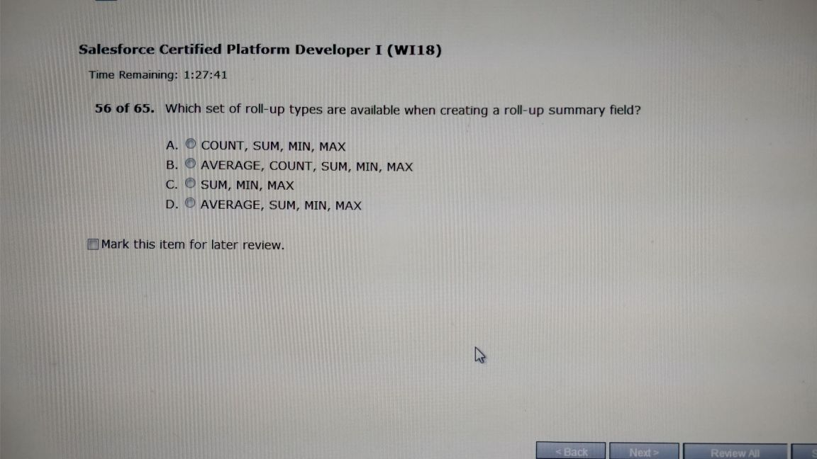

A

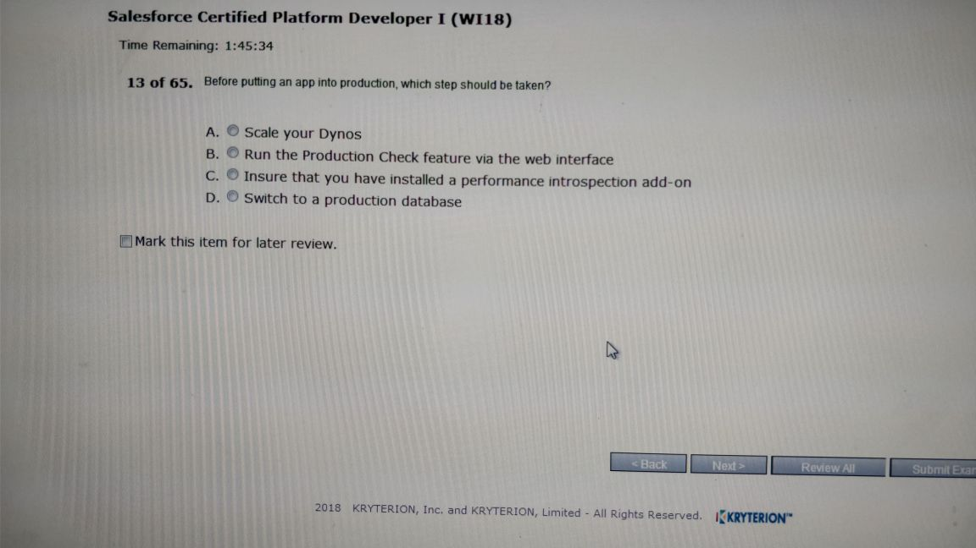

D

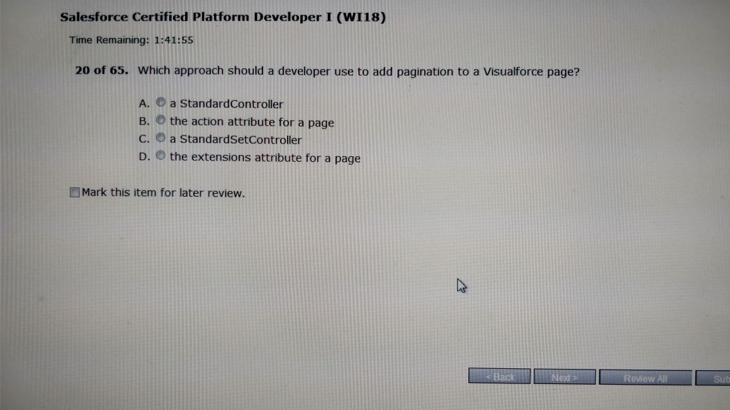

C

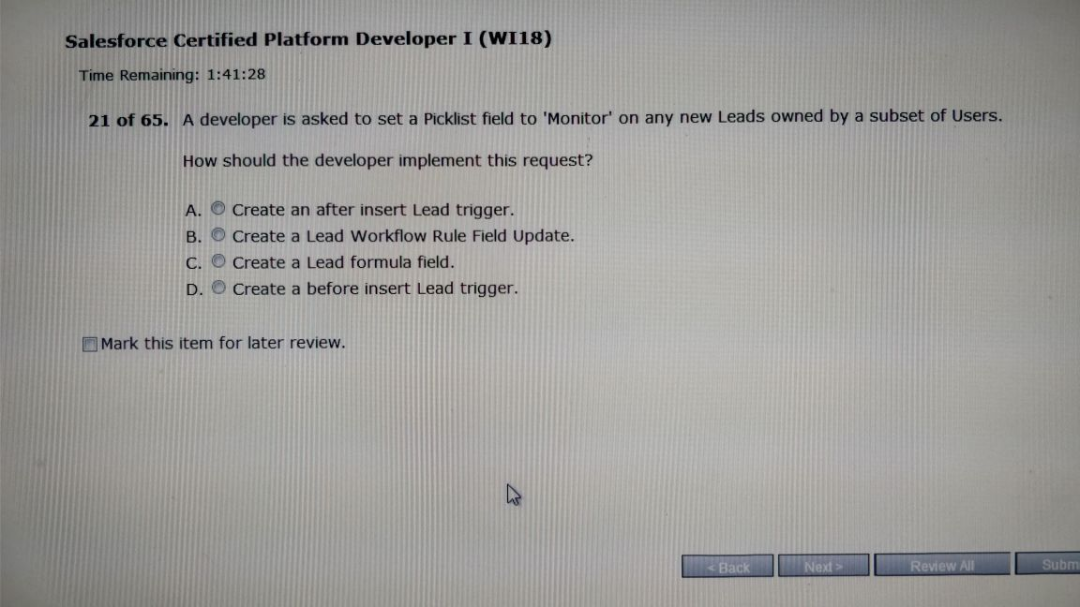

D

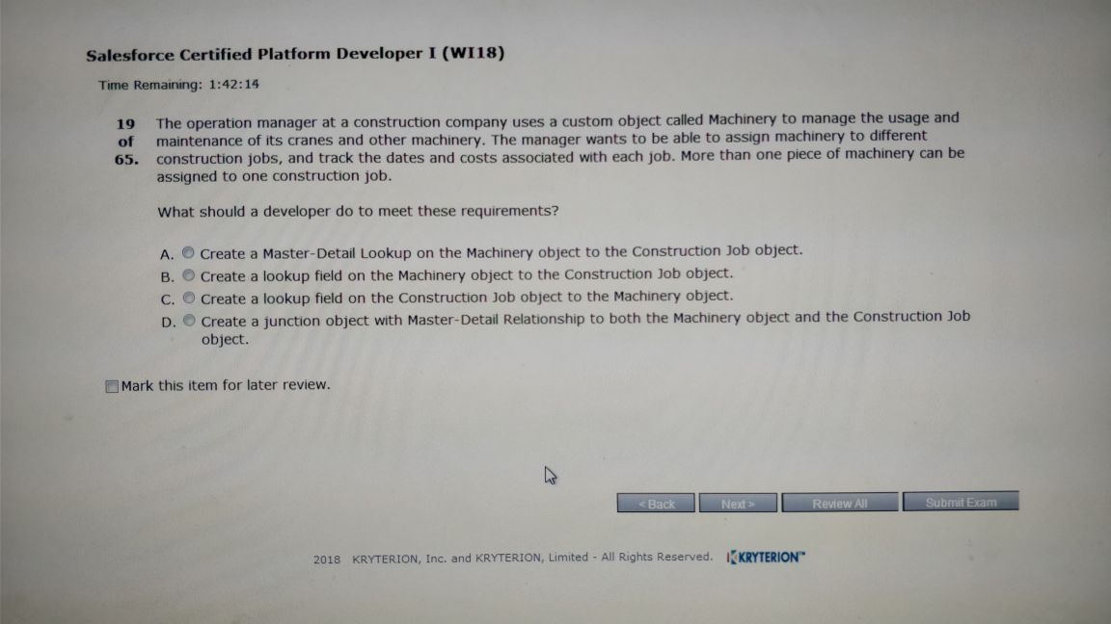

A.

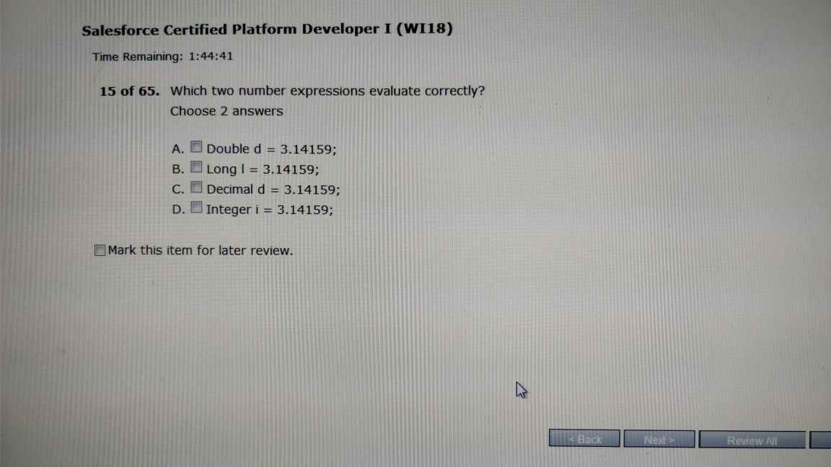

A,C

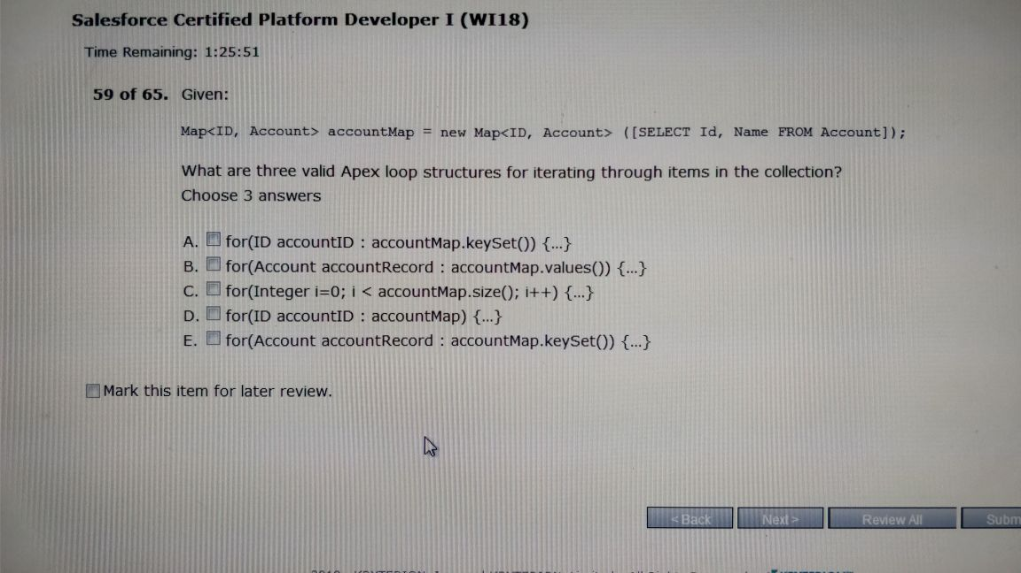

A,B,C

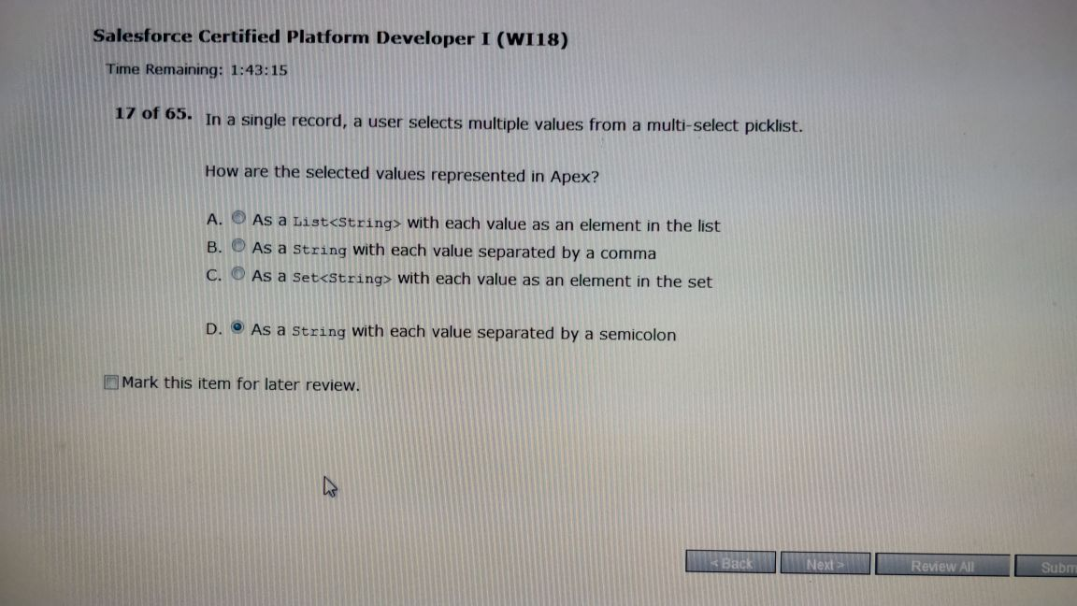

D

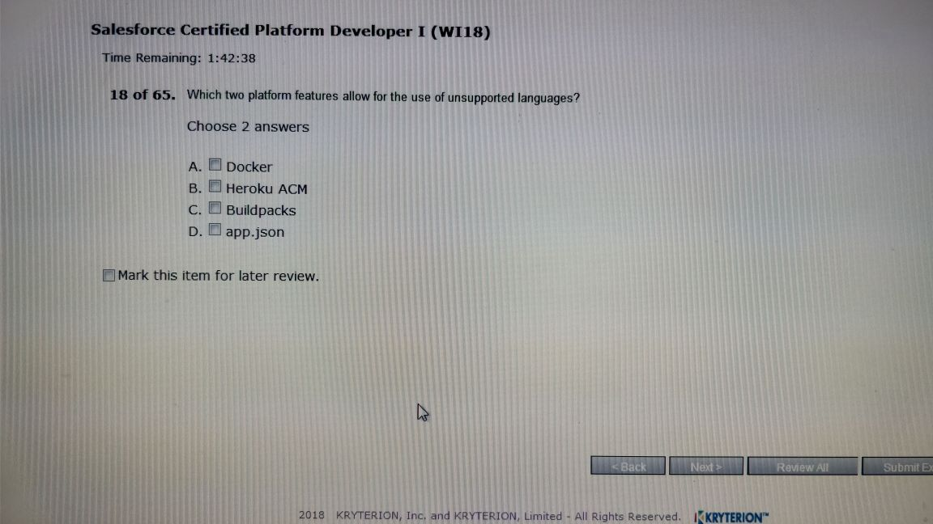

A,C

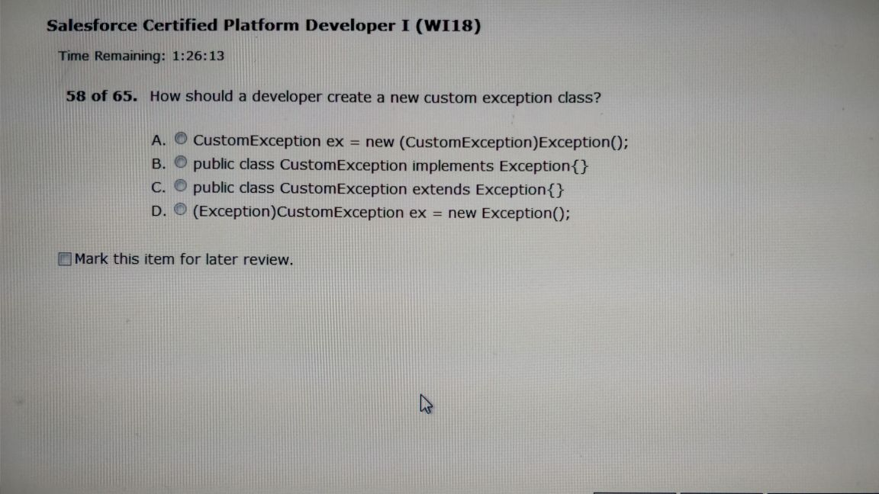

C

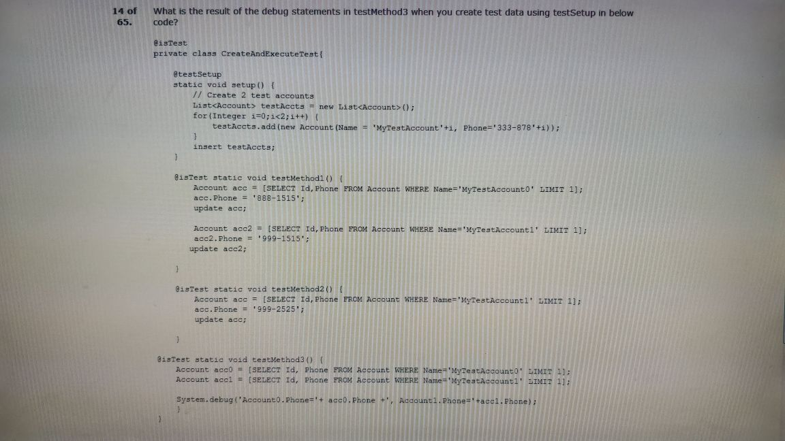

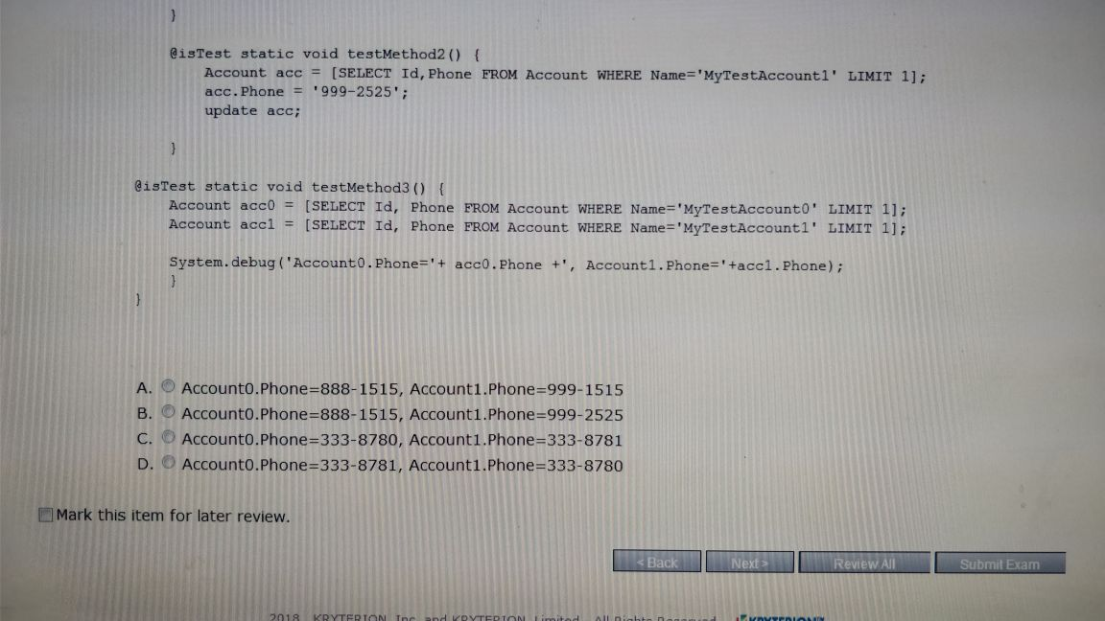

C

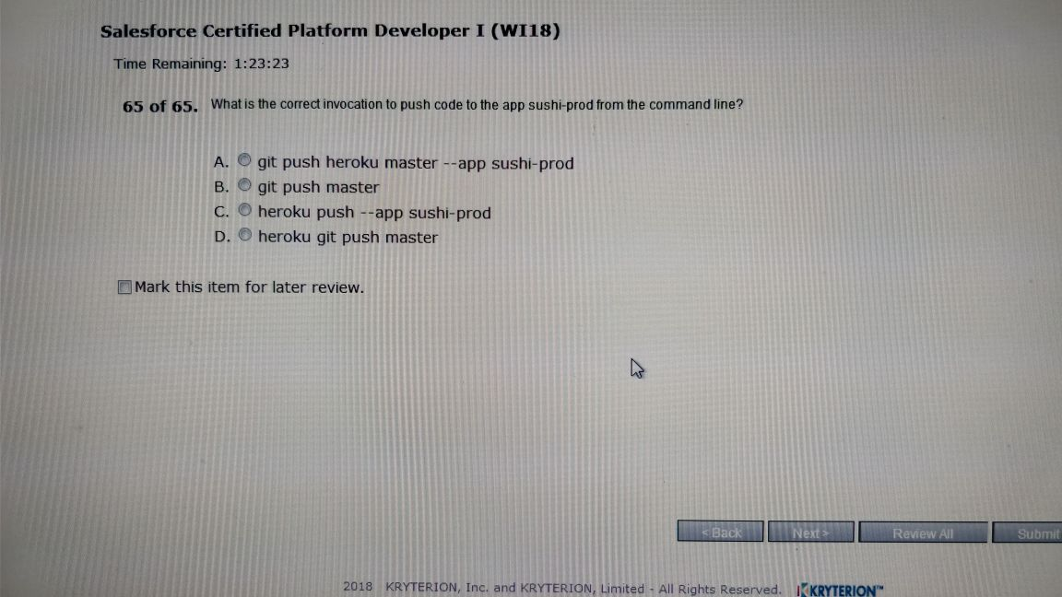

* A ???

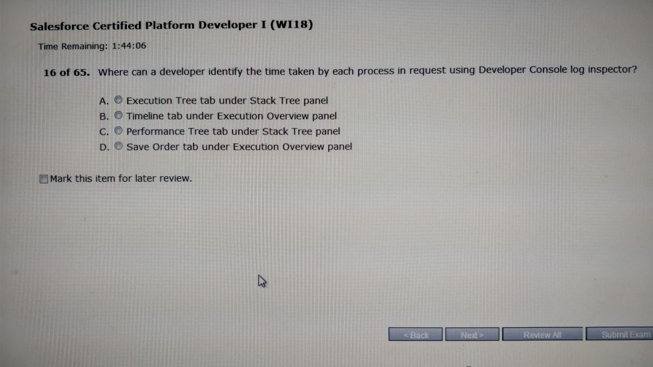

A

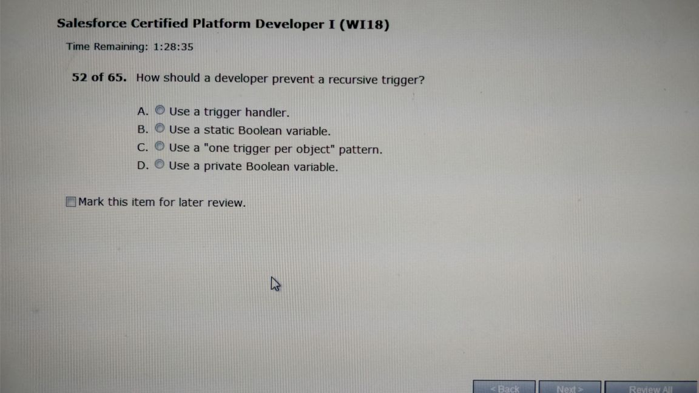

B

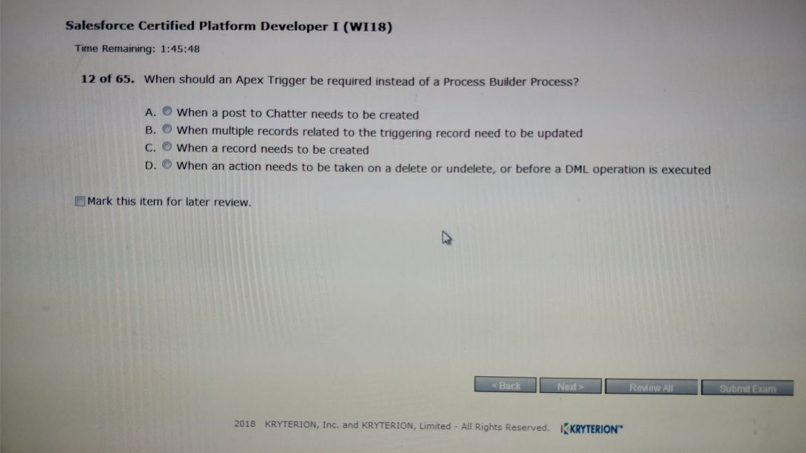

D

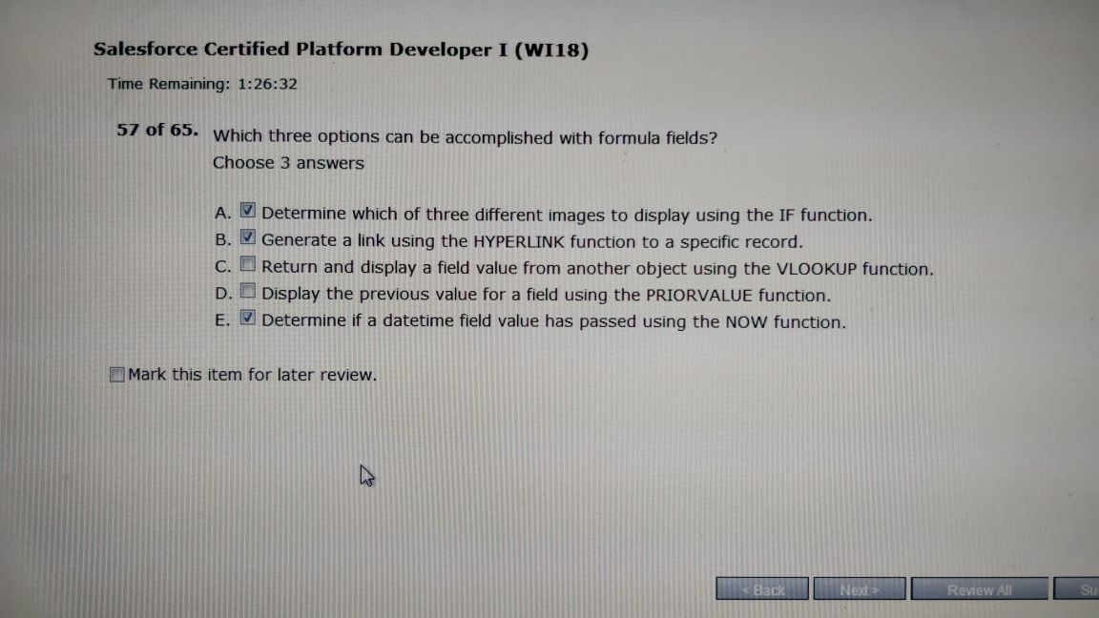

A,B,E

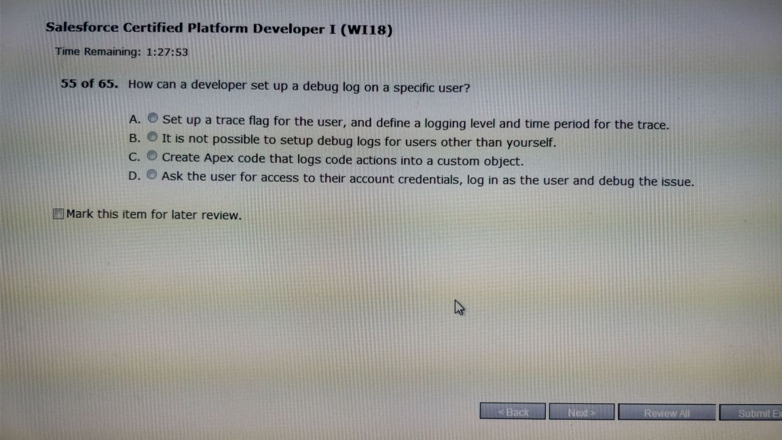

A

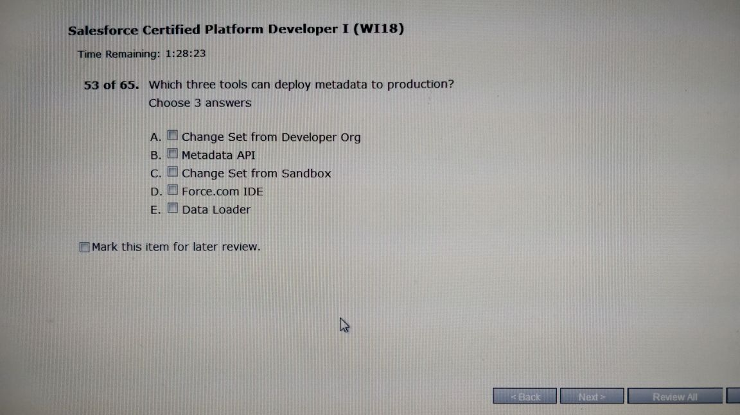

B,C,D

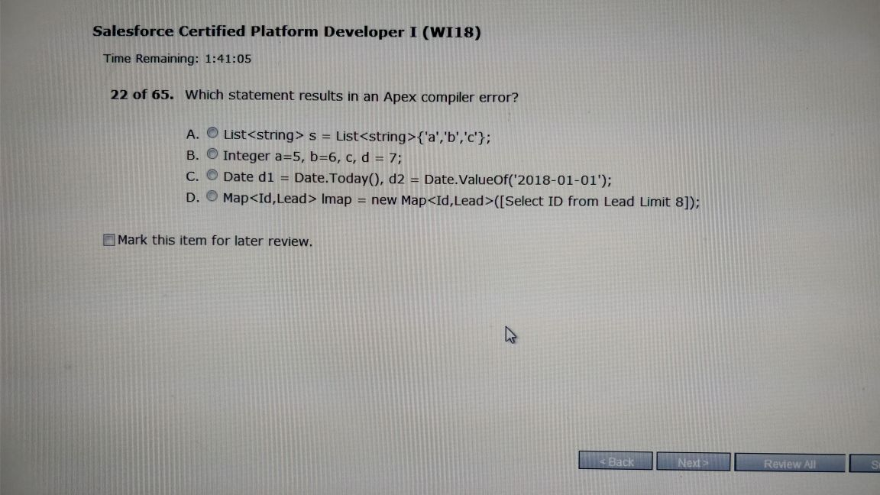

A.

1.Which 8 suite of language supports Heroukuconnect ?

**2.What is the use of HerokuConnect?**

3.what command is used in commandline to push code from Heroku to Production ?

**4.What is the advantage of lightning component ?**

[**5.@SetupData**](mailto:5.@SetupData) **annotation in Test class ?**

6.How can approval process be called automatically ?(process builder, scheduled apex,workflow,email alert)

7.In which datatype number field can be stored in apex ?

8.How can case status picklist value and its recordtype be found in apex ?

**9.one construction job have multiple machinery and one machinery can be used for multiple construction job (answer - junction with master-detail on both objects).?**

10.How can a developer ensure for maintenance plan if opportunity is closed and its annual subscription is expired.?

11.Before deploying app to production, what developer should do ?

12.Where should developer develop managed packaged ?

**13.What is the correct assignment?**

**Answer=Double=3.144; decimal=3.234;**

**14.insert acc;**

**emptyRecycleBin(acc);**

**getlimit,getDmllimit**

**Answer - 2,150**

**15.what is model in MVC framework?**

**answer- custom field on the custom wizard object , Standard account lookup on the contact object.**

**16.what are three ways to add style into visualforce page ?**

**Ans: <apex:stylesheet>,inline css, static resource**

Choose 3 answer

17.what is the use of <ltng:require> tag . choose 3 answer

**18.what are 3 ways to run test class?( Options - apex testexecution from setup menu, test menu in developer console,metadata api)**

19.A new developer has joined the organization and found there are multiple trigger written on same object. what should developer do ?

**20.On page user select multiple values from multipicklist, in what format it will be stored in apex?**

**Ans: As a string with each value separated by a semicolon**

**21.what are 3 ways to deploy to production ?**

**22.Developer has written one unit test method to confirm that the method written for handling exception is properly handle the exception or not.But in test method it is giving exception. What should developer do ?**

**Answer:test method relies on existing data in the database**.

**23.There was q question related to Quote and quotelineitem. So get idea of how these objects are related and etc.**

**24.Select  name ,max() from account group by name is the correct answer when question comes for which query is correct.**

25.A developer has written one method that is used in controller for the vf page. but the same method needs to be used in multiple apex classes. what should developer do ?

26.where developer can see the time taken for the execution in developer console?

27.Scope of static variable in apex class ?

28.To override the standard button functionality what must a developer use in vf page ?

Use standardcontroller in vf page.

29.what should a developer use in <apex:page > attributes to use the standard functionality of the object and its enhanced functionality?

30.When to use standardsetcontroller

31.What is true about withSharing keyword ?

32.When to use custom controller over?